Directions
- Loughborough University Physiotherapy Clinic, 1st Floor Performance Centre, Loughborough University, Loughborough, LE11 3TU
- Telephone: 01509 226240
- Email: physioreception@lboro.ac.uk
Campus Map
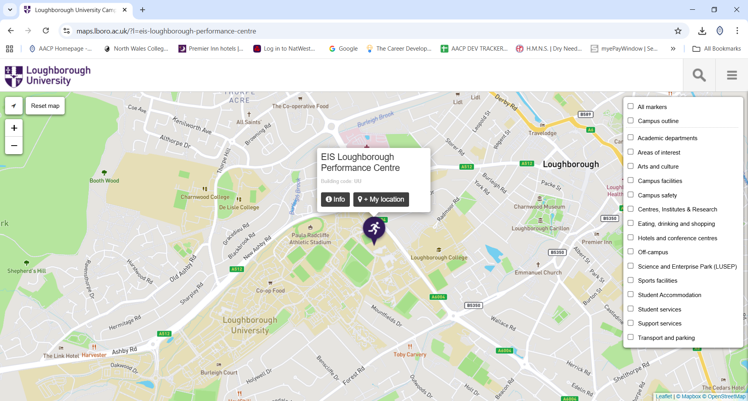

Google Maps Location
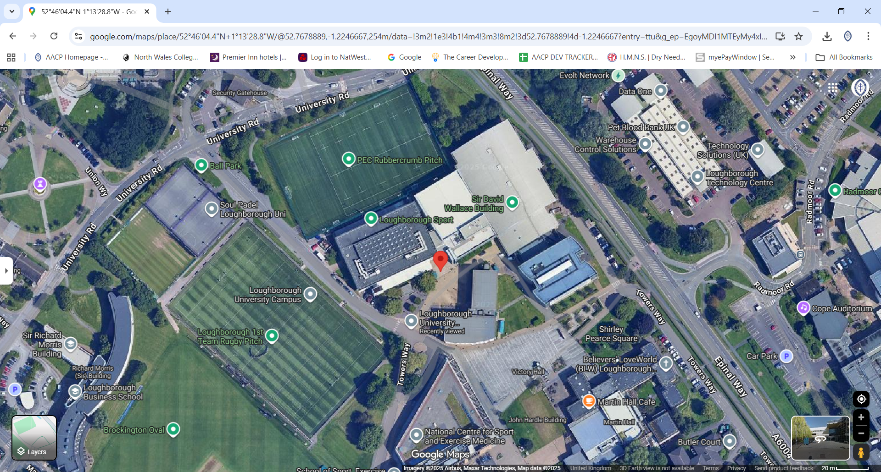

Car Park
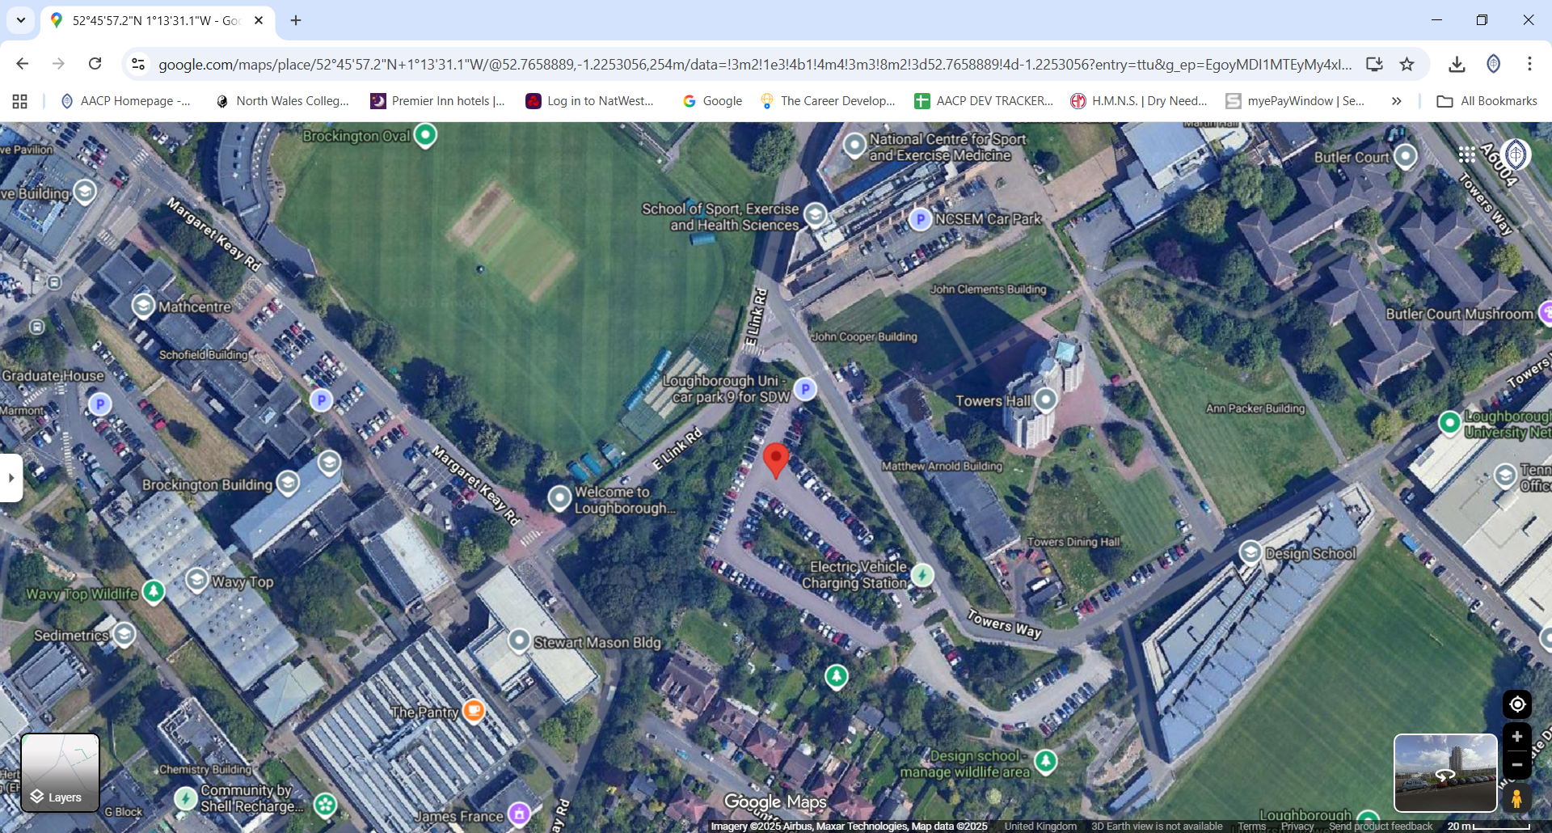

Travelling by car
We are based in the Performance Centre (Building 96), above the Powerbase Gym
- If you are travelling by car, please use the car park links above
Car Park 9
- Please use the main University entrance off Epinal Way. Report to the security gate (you’ll need to go through the visitor’s side and tell them to direct you to the physiotherapy clinic within the Performance Centre)
- Take the first left and drive past the 4G rugby pitch on your right
- Follow the road round until you see a sign for Car Park 9 on your right-hand side – this is the best/nearest place to park
- Once parked you need to walk back the way you have just driven – look out for a sandstone forecourt with willow trees

