Herbprime.co.ltd, Manchester

Address: | Herbprime.co.ltd, Unit 2 Fourways Trading Estate, Longbridge Road, Trafford Park, Manchester, M17 1SW
Tel: | 0800 310 1588
Website: | www.herbprime.com

Please note that lunch is not provided but there is an Asda Supercentre approx. 6 minutes drive from the venue.
Directions to Asda Trafford Park Supercentre, Barton Dock Roadm Stretford, Manchester, M41 7ZA
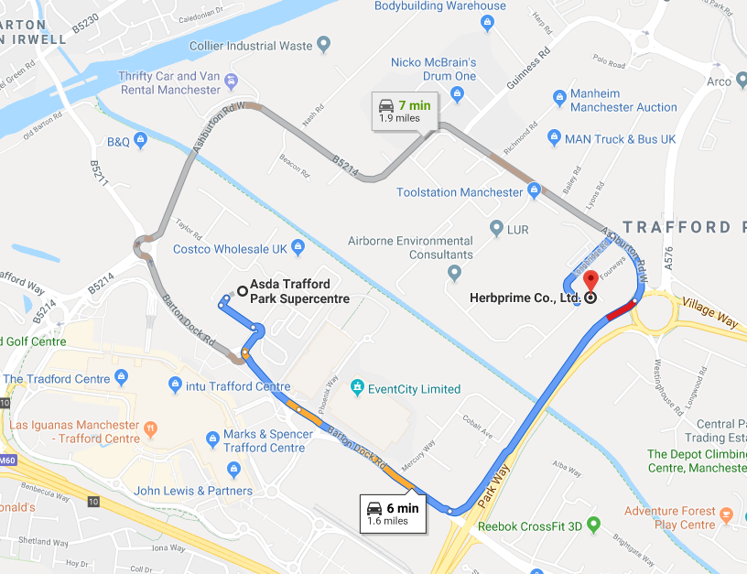

Directions
Please click here for personal directions.

Parking
Free Parking is available onsite.
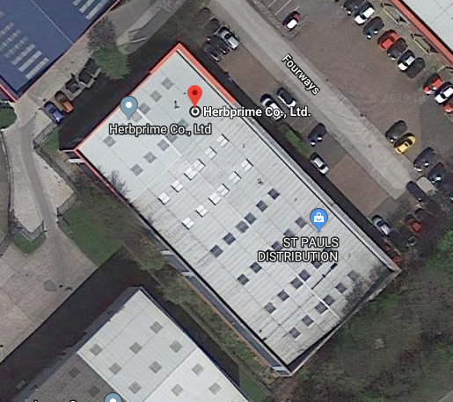

Travelling by Train
The closest railway station to the venue is Trafford Park Railway, which is approx. 7 minutes taxi ride to the venue.
For more information on train times or to book your travel, please click here.

Taxi Companies
- Radio Cars – 0161 236 8033
- Union Cars – 0161 225 5566
- Link Cars – 0161 225 1800

Travelling by Bus
Park Way is the nearest bus stop on the No. 272 and is a 5 minute walk to the venue.
To plan your journey, please click here.

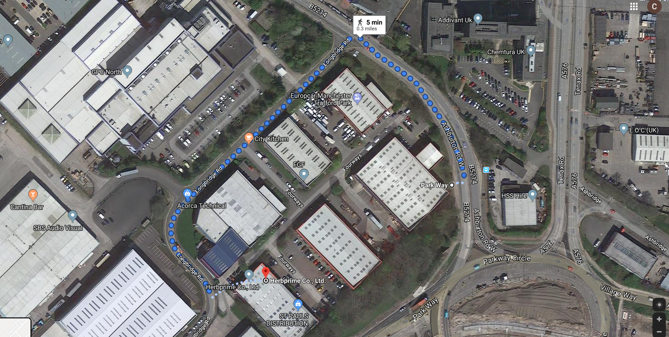

Travelling by Tram
Ladywell Tram (Stop A) (Eccles New Road, M5 5AT) is the nearest stop and will take 7 minutes in a taxi or 36 minutes to walk to the venue.
To plan your journey, please click here.

Please see see below the tram map for your information.
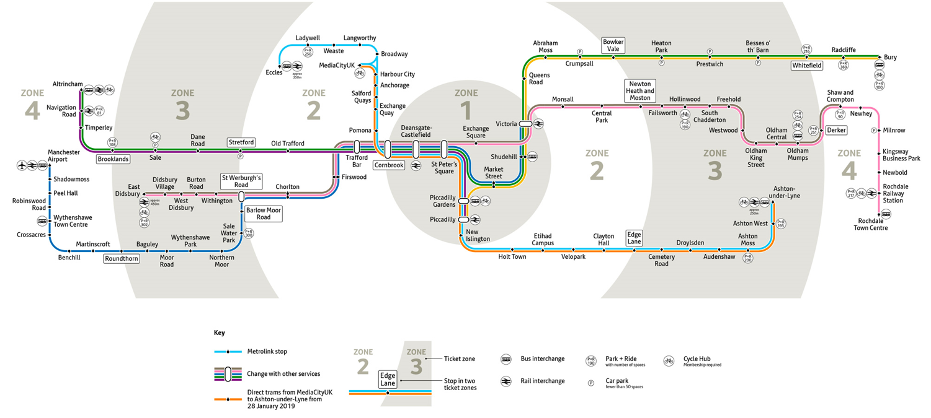

Travelling by Air
Manchester Airport is the nearest airport to the venue, for flight times please click here.

Directions from Airport
By Taxi:
- Via M56 – 31 minutes / 10.1 miles
- Via M56 & M60 – 33 minutes / 10.8 miles
- Via M60 – 38 minutes / 11.2 minutes

Click here for more details

Using Public Transport
- From Cargo Centre (No. X30) – Victoria Tram (Navy Line) – Trafford Bar (No. 250 Intu Trafford Centre) – 1h 38mins
- From Cargo Centre (No. X30) – Manchester Airport (Transpennine Express to Edinburgh, Platform A) – Oxford Road Station (No. 250 Intu Trafford Centre) – 1h 28 mins
- From Cargo Centre (No.103, Piccadilly Gardens), Manchester Airport (Transfpennine Express via Middlesborough) – Oxford Road Station (Intu Trafford Centre) – Westinghouse Road – 1h 27 mins

Click here for more details

Accommodation
- Premier Inn Manchester City (Piccadilly) Hotel, 72 Dale Street, Manchester, M1 2HR
- Travelodge Manchester Upper Brook Street Hotel, 227 Upper Brook Street, Manchester, M13 0HB
- DoubleTree by Hilton Manchester Piccadilly Hotel, One Piccadilly Place, Manchester City Centre, Manchester, M1 3DG
- Holiday Inn Manchester City Centre, 29 Aytoun Street, Manchester City Centre, Manchester, M1 3DT
For a list of hotel price comparisons, please click here

